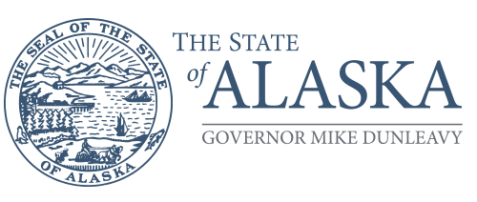Department of Health

DIVISION OF PUBLIC HEALTH
Director’s Office

P.O. Box 110610
Juneau, Alaska 99811-0610
Main: 907.465.3090
Fax: 907.465.4632

TO: Wendy Allen
Department of Health
Division of Public Health
Section of Rural and Community Health Services
Trauma Unit

FROM:

DATE: PHONE: (907)

SUBJECT: Request for Verification Site Visit Relative to Level IV Trauma Facility Capability

Please proceed with arrangements for a verification visit to the above facility. Please forward materials essential for the visit. We understand that:
Verification is formal and may result in issuance of a certificate by the State of Alaska.
A written report of the evaluation is provided.
Designation of facilities as Level IV trauma centers will be made by the State of Alaska based on recommendations from the verification surveyors.

Our preferred time frame for the visit is:
Earliest date:
Latest date:

Contact information for Clinical Director:
(Name)
(Address)
(Telephone Number)

Signature and typed name and title of person authorized to sign this application (typically Chief Executive Officer)
(Signature)
(Name)
(Title)

